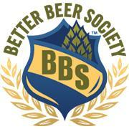
BRAND ADVOCATE SAMPLING REPORT
Sampler’s Name: ________________________________ Sampling Date and Hours: ____________________________
Location Name: __________________________________ Location Contact: _____________________________________
Brand: _____________________________________________
PRODUCT INFO
BRAND/STYLE | DATE CODE | BRAND/STYLE | DATE CODE
SAMPLING INFO
Total $ Sold: _________________ Impressions: _________ Cups: _________ Cups Provided By: ______________________
Cans/bottles opened: _______ Purchase Amount: __________________ Purchase Method: Personal / BBS Card
SAMPLER NOTES
Some questions to get you started:
- Which beer sparked the most conversation? - What were customers general perception/comments of the brewery?
- What was the retailer's impression of the beer? Did you hear them selling the beer or sampling event at the counter?
- Did the brewery have a good visible presence in the store? (POS/Signage, eye level on cooler shelf, floor stacks, etc.)
- Were you able to sell more beer based on its freshness dates? Was there an issue finding fresh beer?

